AFRICAN SOLIDARITY CIVIC ORGANISATION NPC (ASCO)
Donations and Refunds Policy
BOARD-APPROVED FINAL DOCUMENTATION
FINAL DOCUMENTATION — BOARD APPROVED; EXECUTION / FILING DETAILS TO BE RECORDED
This document records the Board-approved ASCO governance model and policy position. Legal effectiveness, execution, statutory-register updates and filing or registration requirements must be completed by the authorised persons and recorded in the approval register. The Memorandum of Incorporation remains subject to the Companies Act 71 of 2008 and applicable filing requirements.
DOCUMENT CONTROL
Version: 1.0 | Prepared and Board-approved: 10 September 2026 | Resolution reference: To be entered in the approval register | Effective date: To be recorded where applicable | Next review: To be recorded
1. STATUS AND PURPOSE
This policy governs donation acceptance, restrictions, records, acknowledgements and refunds. It does not create PBO or section 18A approval.
2. TAX STATUS NOTICE
ASCO is not represented as an approved PBO and does not issue section 18A receipts unless separately approved by SARS. PBO and section 18A approval are separate processes.
3. ACCEPTANCE
ASCO may accept gifts consistent with its objects and independence. It may decline or return gifts that are unlawful, revocable, benefit-conferring, reputationally harmful, excessively restricted or impossible to administer.
4. RESTRICTIONS
A programme designation is a preference unless ASCO confirms a restricted gift in writing. Restricted grants are separately tracked and reported.
5. RECEIPTS AND REFUNDS
ASCO may issue an ordinary acknowledgement or receipt. It is not a section 18A receipt. Refunds are considered for duplicate, mistaken, unlawful or unadministerable payments under Board-approved procedures.
6. CONTROLS
Donor due diligence, conflict checks, records, dual approval, privacy and anti-fraud controls apply.

Place of approval / execution: 49 Rif Road, Manor Gardens, Durban, KwaZulu-Natal, 4001, South Africa
BOARD APPROVAL SIGNATURES
The following signatures are copied from the signed ASCO documents supplied for this purpose. They record Board approval/acknowledgement in the stated capacities; statutory effectiveness, filing and authority remain subject to the applicable approval and filing process.
CHAIRPERSON / FOUNDER  Ms Busisiwe Makhosi Shandu  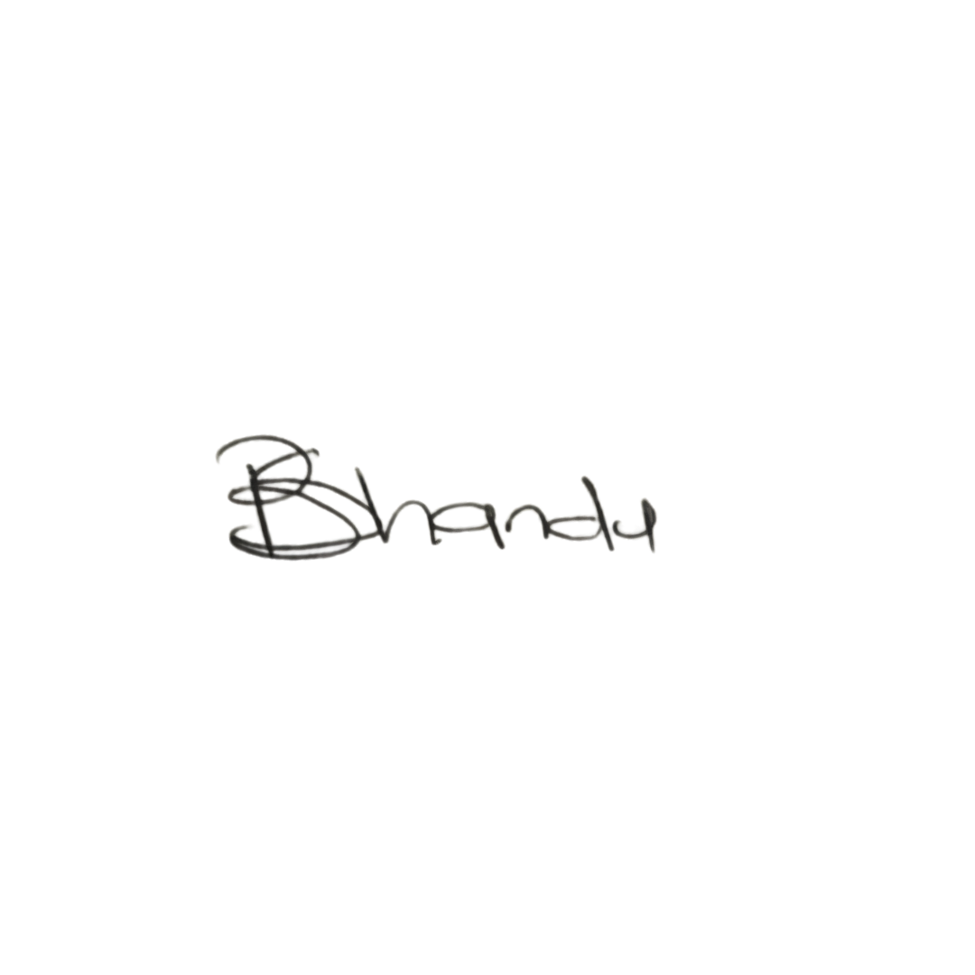  Date: 6 September 2026  Signature copied from supplied signed document | DIRECTOR: ICT AND COMMUNICATIONS  Mr Thapelo Nelson Maqalika  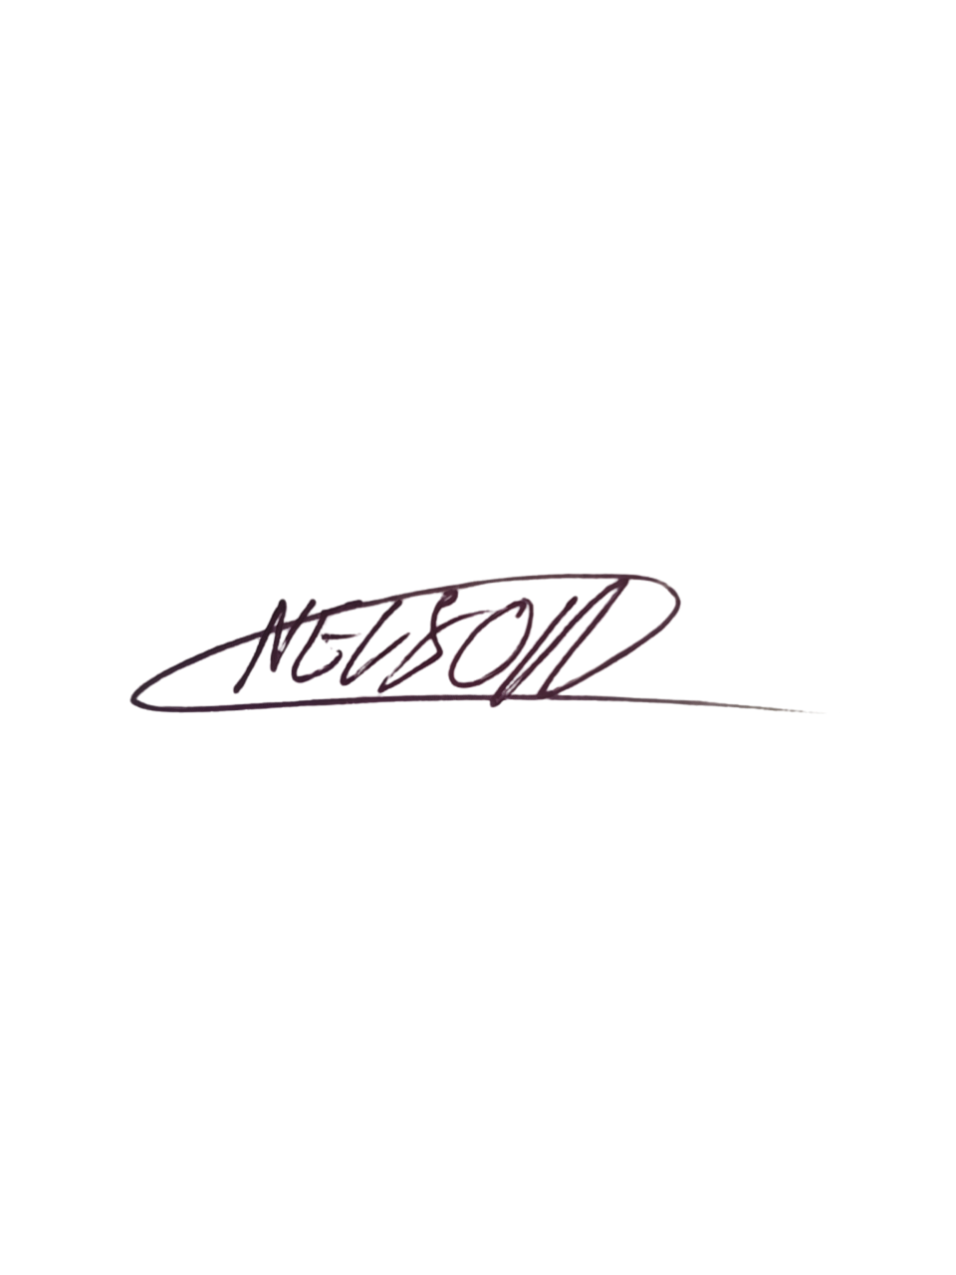  Date: 6 September 2026  Signature copied from supplied signed document
EXECUTIVE DIRECTOR  Mr Bhekisisa Shandu  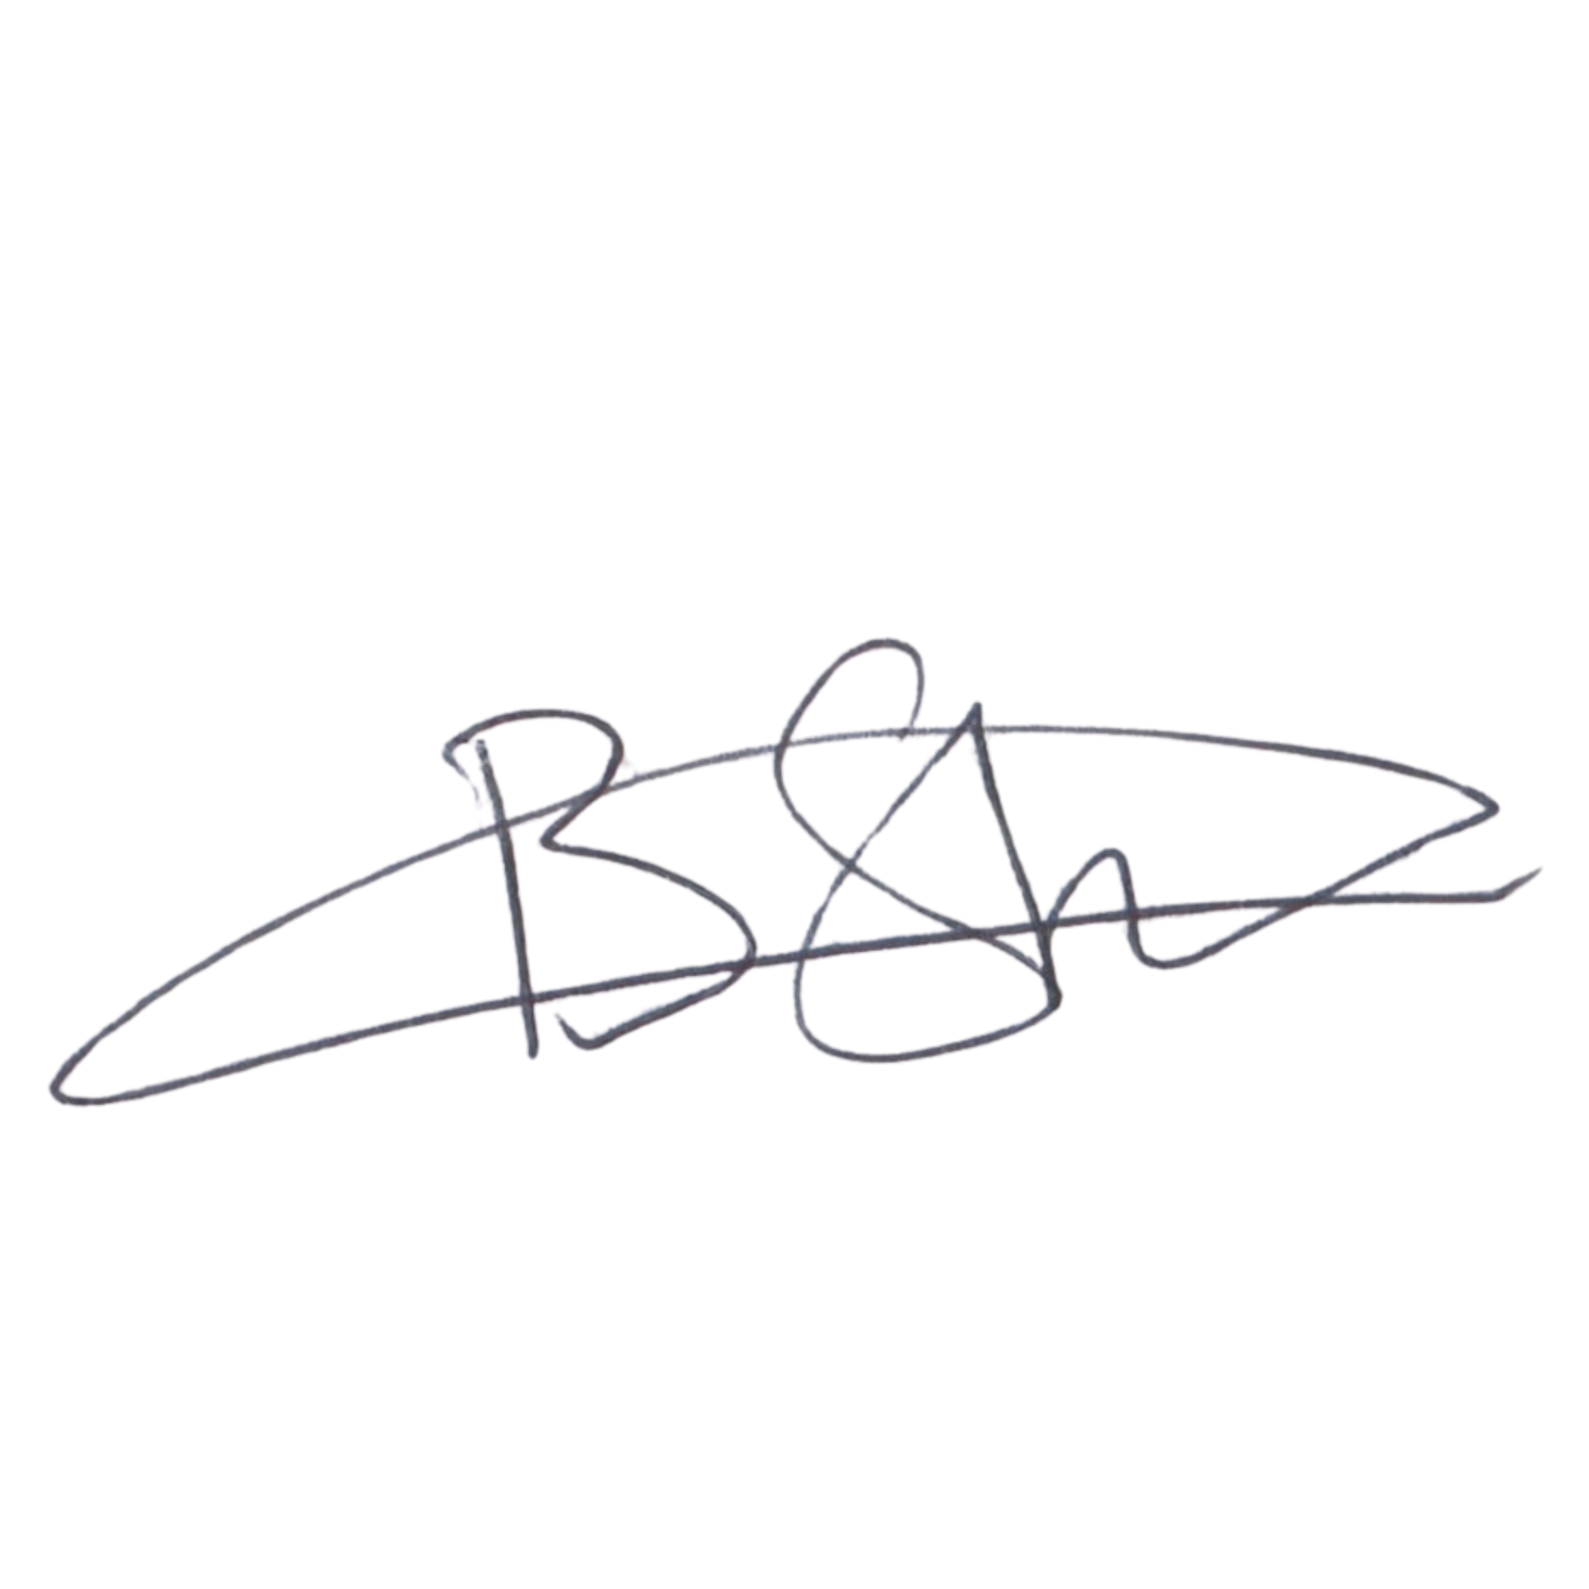  Date: 6 September 2026  Signature copied from supplied signed document | DIRECTOR: PEOPLE AND CULTURE / FINANCE AND PROCUREMENT  Mr Khulekani Gumede  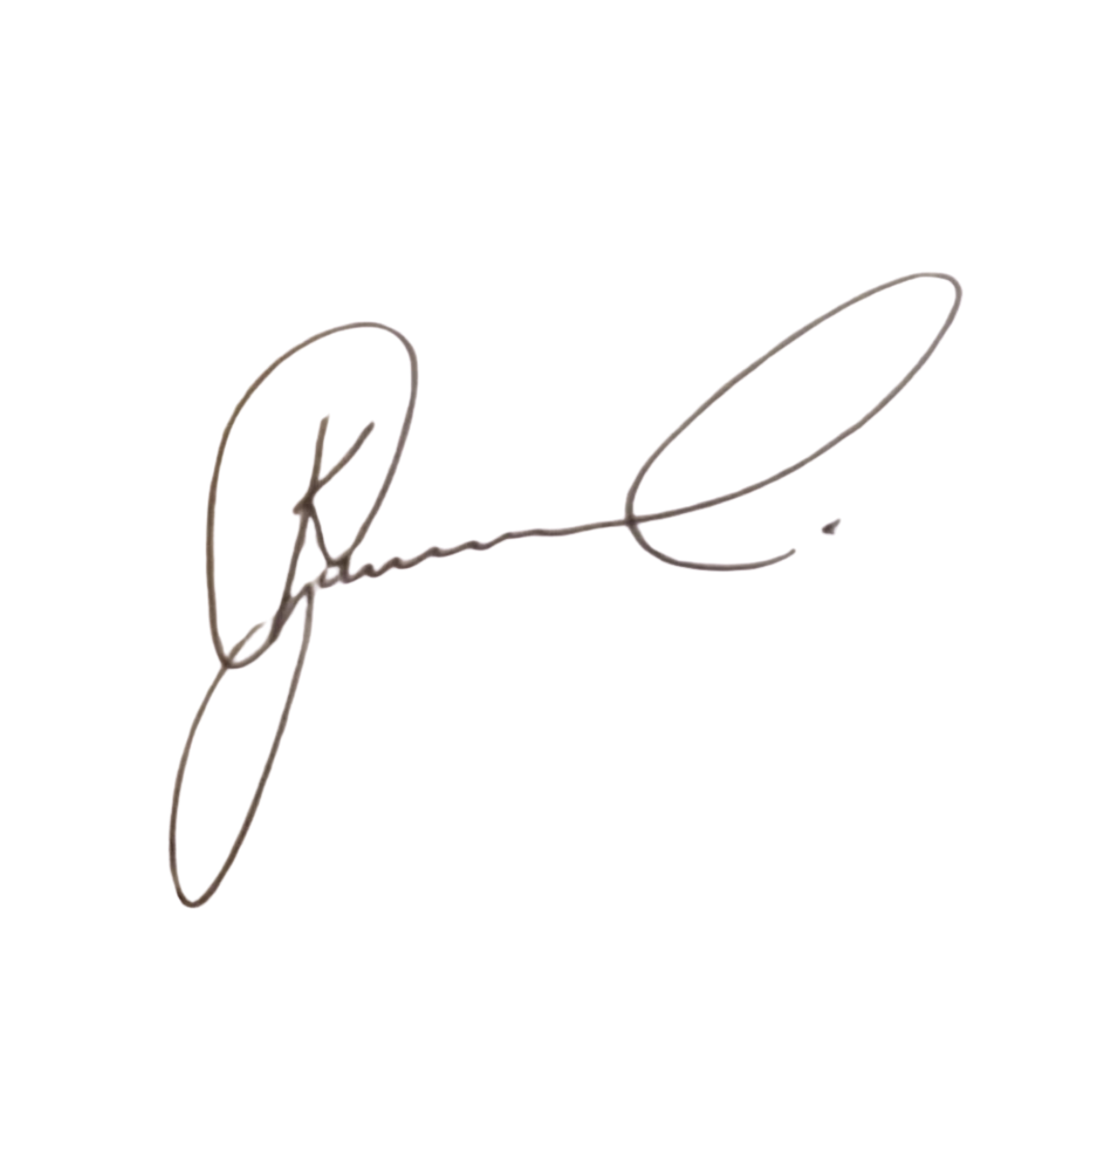  Date: 6 September 2026  Signature copied from supplied signed document

